Preliminary Drawings Ecuador Plant

**Entire plant (minus entrance tank):**

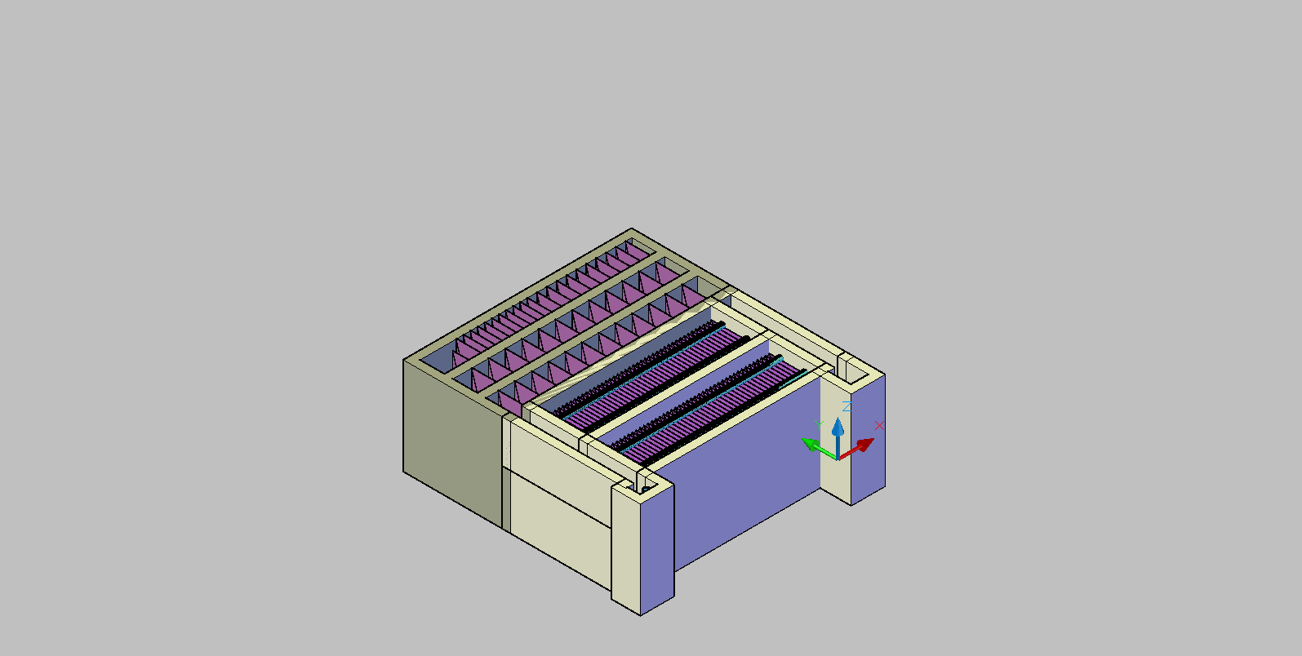

**Flocculator**

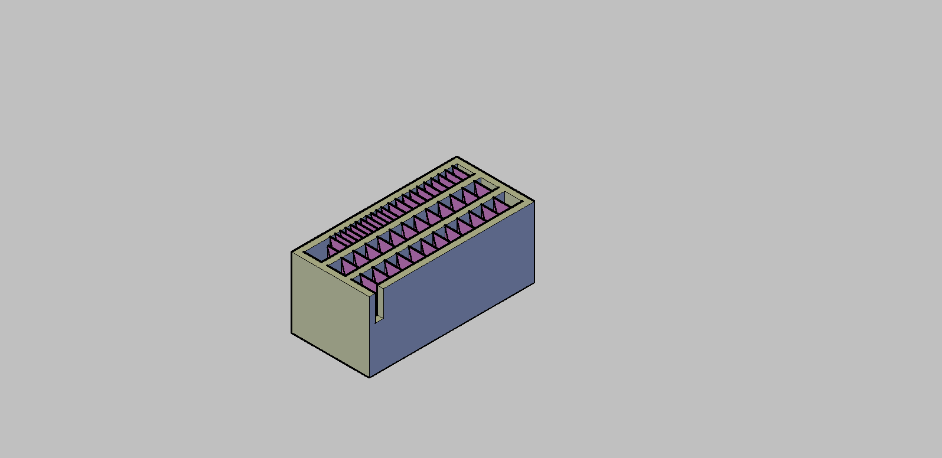

LFlocChannel

WFlocChannel

**Inlet channel**

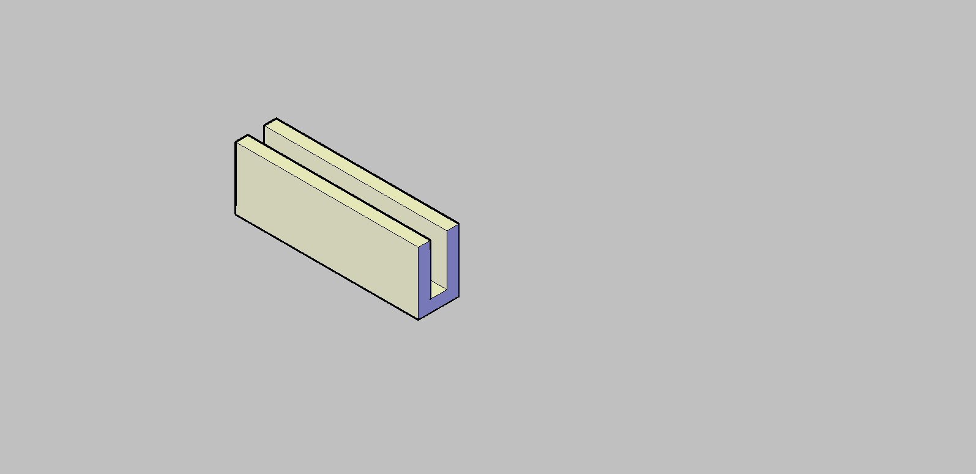Top view Isometric view

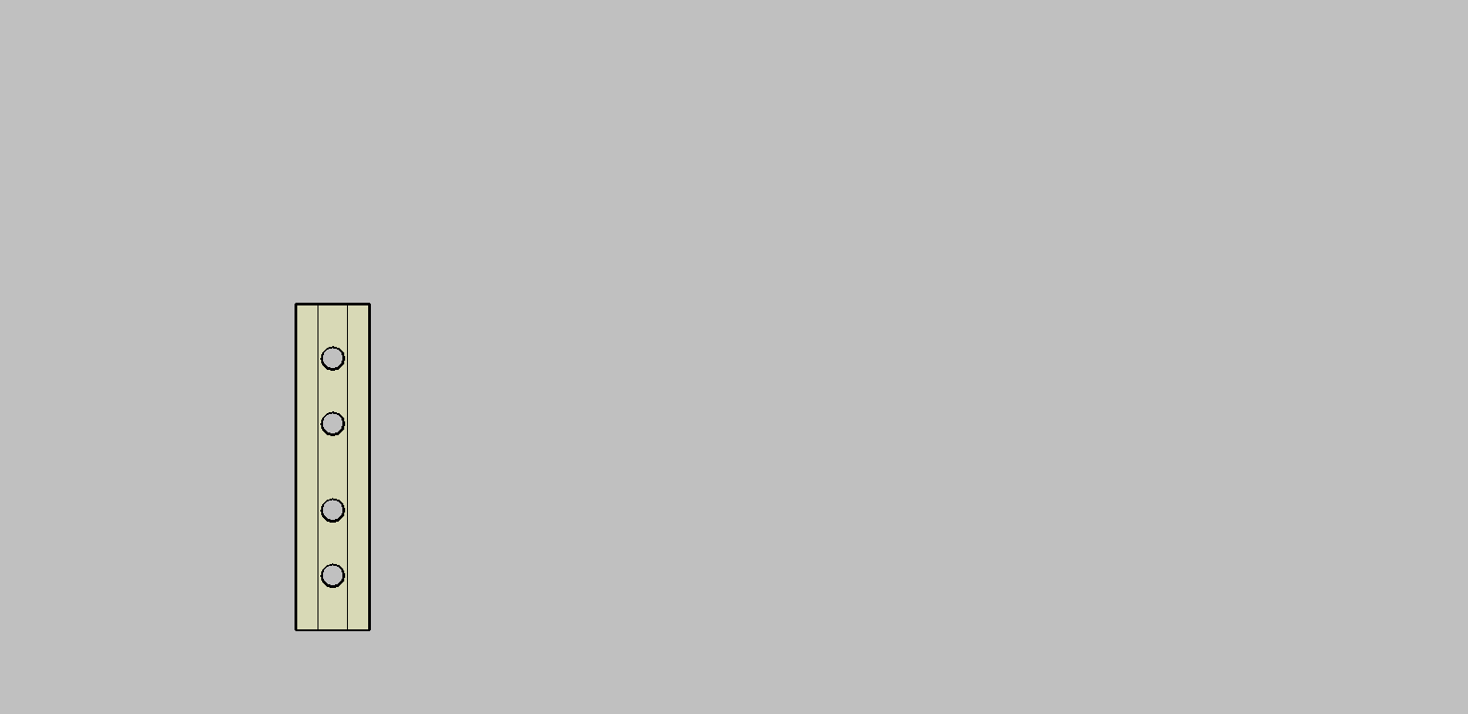

HInletChannel

WInletChannel

LChannel

**Exit Channel**

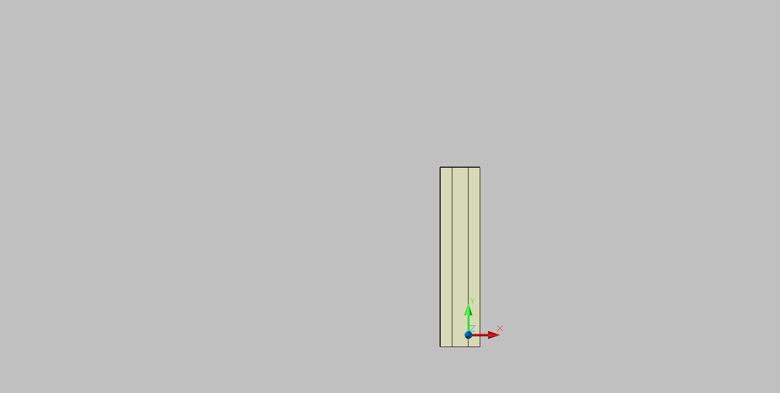Top View Isometric View

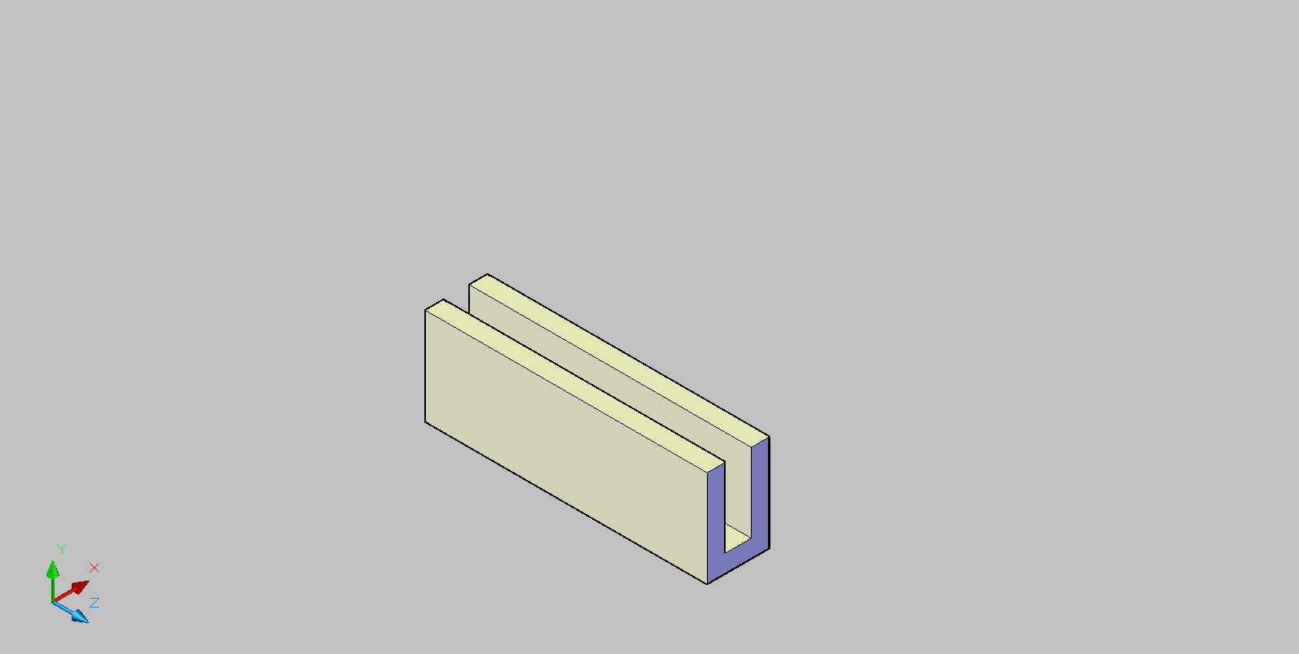

WExitChannel

HExitChannel

LExitChannel

**Sed Tank**

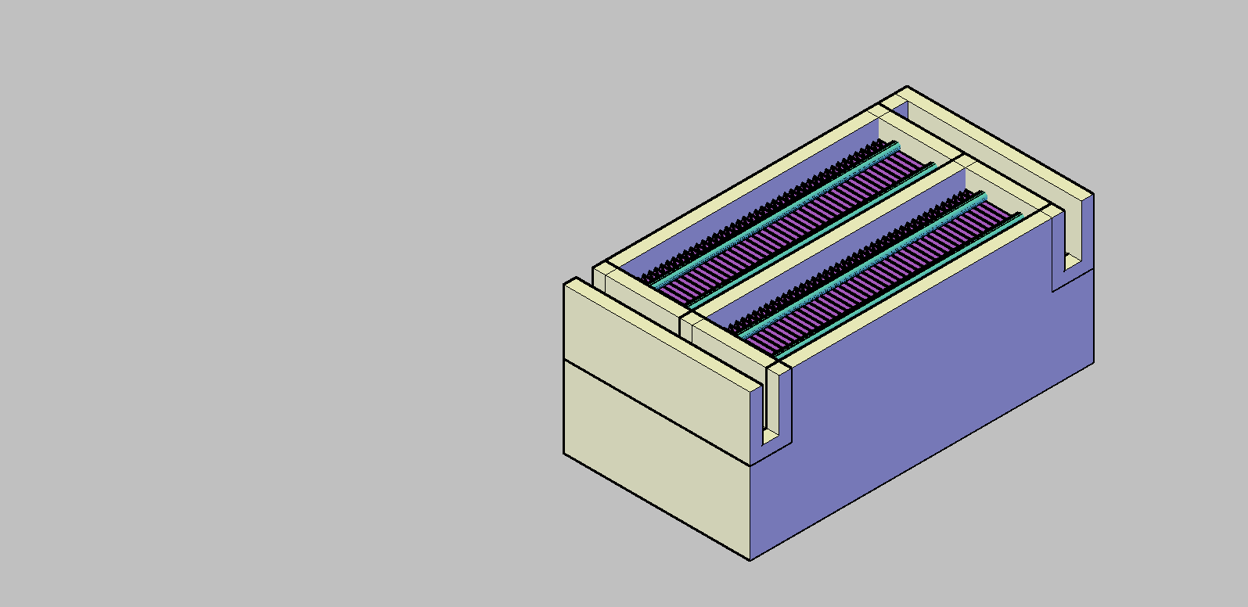

LSed

wSed

HSed